Bangladesh Medical Association (BMA)
List of Life Member-27
37. BMA Manikganj Branch

Sl No | Voter No | Voter Details
1 | Voter No  LM-3700001  No Image | DR. M.A QUADER  F/Name: Md. Roushan Ali  M/Name:  BM & DC Reg. No:  NID:  Cell:  Address: Resident Medical Officer  District Hospital,  Manikgonj.  Blood Group:
2 | Voter No  LM-3700002  No Image | DR. MD. NURUL GANI  F/Name:  M/Name:  BM & DC Reg. No:  NID:  Cell:  Address: TRANSFERED to BMA Dhaka City  LM-1404058  Blood Group:  TRANSFERED to BMA Dhaka City  LM-1405543
3 | Voter No  LM-3700003  No Image | DR. MUZAFFAR UDDIN AHMED  F/Name: Mojer Ali  M/Name:  BM & DC Reg. No:  NID:  Cell:  Address: TRANSFERED to BMA Dhaka City  LM-14020  Blood Group:
4 | Voter No  LM-3700004  No Image | DR. MD. HABIL UDDIN BHUIYAN  F/Name: Md. Tafil Uddin Bhuiyan  M/Name:  BM & DC Reg. No:  NID:  Cell:  Address: THC Singair  Manikgonj  Blood Group:
5 | Voter No  LM-3700005  No Image | DR. KAZI SHAHADAT HOSSAIN  F/Name: Dr. Kazi Taiyebur Rahman  M/Name:  BM & DC Reg. No:  NID:  Cell:  Address: Thana Health Comolex  Saturia  Manikgonj.  Blood Group:
6 | Voter No  LM-3700006 | DR. MD. ABDUL AWAL  F/Name: Md. Arshed Ali  M/Name:  BM & DC Reg. No:  NID:  Cell:  Address: Medical Officer  Modernised Sadar Hospital,  Manikgonj.  Blood Group:
7 | Voter No  LM-3700007 | DR. A. R. ROQUIBA BEGUM  F/Name: Late Dr. M.A. Rashid  M/Name:  BM & DC Reg. No:  NID:  Cell:  Address: Medical Officer,  Clinic Sadar,  Manikgonj  Blood Group:
8 | Voter No  LM-3700008  No Image | DR. REZA MD. ZAMAN  F/Name: Md. Abdul Jabber  M/Name:  BM & DC Reg. No:  NID:  Cell:  Address: R.M.O.,  Singair THC  Manikgonj.  Blood Group:
9 | Voter No  LM-3700009  No Image | DR. ALI ZELQUED AHMED  F/Name: Al Haj Faiz Ahmed  M/Name:  BM & DC Reg. No:  NID:  Cell:  Address: Vill. Irta , P.O.- Irta,  P.S. Shingair,  Manikgonj.  Blood Group:
10 | Voter No  LM-3700010 | DR. NARENDRA KUMAR ROY  F/Name: Ananda Kumar Roy  M/Name:  BM & DC Reg. No:  NID:  Cell:  Address: Niramoy Nursing Home,  27/1, Gangadhar Potty,  Manikgonj  Blood Group:
11 | Voter No  LM-3700011  No Image | DR. MD. SHAH ALAM  F/Name: Md. Noor Hossain  M/Name:  BM & DC Reg. No: 9000  NID:  Cell:  Address: Thana Health Comolex, FPO. Ghior  Manikgonj.  Blood Group:
12 | Voter No  LM-3700012  No Image | DR. MD. RASHIDUZZAMAN  F/Name:  M/Name:  BM & DC Reg. No:  NID:  Cell:  Address: Civil Surgeon, Manikgonj.  Blood Group:
13 | Voter No  LM-3700013  No Image | DR. MD. ABDUR RAZZAQUE  F/Name:  M/Name:  BM & DC Reg. No:  NID:  Cell:  Address: TH & FPO., Horirampur,  Manikgonj.  Blood Group:  TRANSFERED to BMA Dhaka City  LM-1405543
14 | Voter No  LM-3700013  No Image | DR. MD. ABDUR RAZZAQUE  F/Name:  M/Name:  BM & DC Reg. No:  NID:  Cell:  Address: TH & FPO., Horirampur,  Manikgonj.  Blood Group:  TRANSFERED to BMA Dhaka City  LM-1405543
15 | Voter No  LM-3700014  No Image | DR. MD. ABDUS SAMAD  F/Name: Md. Yeazuddin  M/Name:  BM & DC Reg. No:  NID:  Cell:  Address: Thana Health Comolex  Singair, Manikgonj.  Blood Group:
16 | Voter No  LM-3700015  No Image | DR. MD. FAROQ UZZAM  F/Name: Md. Emsada Ali Miah  M/Name:  BM & DC Reg. No:  NID:  Cell:  Address: Nabogram Sub-Centre,  Manikgonj  Blood Group:
17 | Voter No  LM-3700016 | DR. MUKTARA BEGUM  F/Name: Dr. Hasan Ali  M/Name:  BM & DC Reg. No:  NID:  Cell:  Address: Sadar Upazila Health Complex,  Manikgonj.  Blood Group:
18 | Voter No  LM-3700017  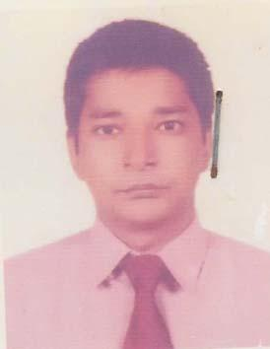 | DR. RAJIB BISWAS  F/Name: Satyendra Narayan Biswas  M/Name: Shipra Lahiri  BM & DC Reg. No: 42486  NID: 5612247874446  Cell: 01195198416  Address: Vill+Post+P.S- Ghion, Dist: Manikgonj  Blood Group: B+
19 | Voter No  LM-3700018  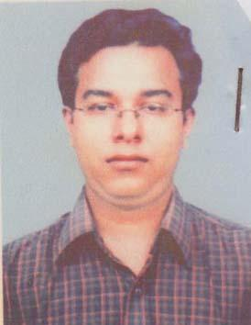 | DR. SUJON KUMAR ROY  F/Name: Shamal Kumar Roy  M/Name: Shibani Rani Roy  BM & DC Reg. No: 42331  NID:  Cell: 01711373953  Address: South Dasara, Manikgonj, Medical Officer, Sadar Hospital  Blood Group: A+
20 | Voter No  LM-3700019 | DR. A.K.M. SHARIFUL ALAM  F/Name: A.K.M. Shamsul Alam  M/Name: Rashida Khatun  BM & DC Reg. No: 16738  NID: 2694810976941  Cell: 01711401903  Address: Consultant (Eye) Adhunik Sadar Hospital, Manikganj  Blood Group: A+
21 | Voter No  LM-3700020  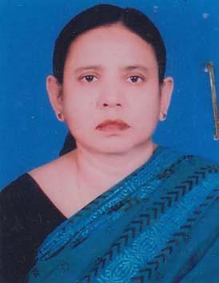 | DR. KRISHNA ROY  F/Name: Late Chitta Ranjan Roy  M/Name: Bina Pani Roy  BM & DC Reg. No: 14005  NID: 5624603113165  Cell: 01711402648  Address: 43, Gongadhar Patti, Manikgonj  Blood Group: O-
22 | Voter No  LM-3700021  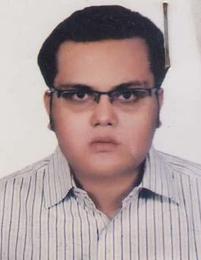 | DR. KALLOL DEY  F/Name:  M/Name:  BM & DC Reg. No: 52425  NID: 9196203121220  Cell: 01732602861  Address: 15/4, Tollarbagh, 2nd lane, Mirpur-01, Dhaka  Blood Group: O-  TRANSFERED to BMA Dhaka City  LM-1405543
23 | Voter No  LM-3700022 | DR. MOHAMMAD ZIAUR RAHMAN  F/Name: Late Md. Moazzem Hossain.  M/Name:  BM & DC Reg. No:  NID:  Cell:  Address: b  Blood Group:
24 | Voter No  LM-3700023 | DR. RATUL SARKAR  F/Name: Dr. Umesh Chandra Sarkar  M/Name: Dr. Krishna Roy  BM & DC Reg. No: 59383  NID: 5624603113119  Cell: 01713013475  Address: 43, Gangadhan Patti, Sadar, Manikgonj  Blood Group: B-
25 | Voter No  LM-3700024  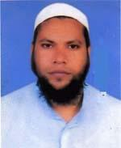 | DR. MOHAMMAD MONZUR ALAM  F/Name: Nur Muhammad Khan  M/Name: Nurjahan Khan  BM & DC Reg. No: 37889  NID: 19775618225443063  Cell: 01911953325  Address: 250 Bed District Hospital Manikgonj  Blood Group: AB+
26 | Voter No  LM-3700025 | DR. A.B.M. TOHIDUZZAMAN  F/Name: Al-haz Md. Abdur Rashid Hawlader  M/Name: Late Mrs. Pyara Begum  BM & DC Reg. No: 43053  NID: 19792699040721084  Cell: 01716619843  Address: Sadar Upozila Hospital, Manikgong,  Blood Group: A-
27 | Voter No  LM-3700027 | DR. MD. AMINUR RAHMAN  F/Name: Md. Shahab Uddin  M/Name: Mrs. Rahima Khatun  BM & DC Reg. No: 20062  NID: 19645617028000001  Cell: 01816852535  Address: Jr, Consultant Orthosurgery sadar Hospital, Manikgong.  Blood Group: O+

